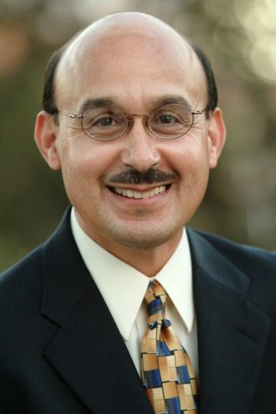

BIO
Frederiq B. Gomez

Frederiq B. Gomez was born in Glassell Park, which is in northeast Los Angeles to hard working yet disenfranchised parents. He attended Eagle Rock and Franklin High Schools, in 1973 after graduating, he joined the United States Marine Corps, and served four distinguished years, two of which were in Vietnam. After Vietnam he served as a Presidential Honor Guard at the Carter White House Heads of State ceremonies and also served as a burial honor guard for the fallen as they were laid to rest at Arlington National Cemetery.

After leaving the Marine Corps, he became a Catholic Lay Missionary in Mexico serving the poor and the disenfranchised near Tijuana as a part of Catholic Charities for one year. In 1979, he joined a Catholic Religious Organization that prepares its seminarians to become Catholic Priests while they volunteer with CARITAS - Catholic Charities of Latin America. However, because Priests in Mexico are not permitted to serve the poor outside of their respective parishes, Mr. Gomez decided to decline ordination at that time in order to work full time serving the poor in Mexico and South America.

While a volunteer for CARITAS - Catholic Charities of Latin America, he was hired as a full time employee and was appointed as their first Human Resource Manager. From this point, Frederiq would serve in various senior capacities from Chief Operations Officer to Vice President of Operations and Development. He managed to strategically move CARITAS - Catholic Charities Latin America from a three million dollar organization to twenty-five million in six years. In 1996, he was appointed by the Board of Directors to the position of Chief Executive Officer to oversee ten regional offices from Tijuana, Mexico to Peru, South America and a compliment of over 2300 employees and volunteers. In 1997, he was elevated to the position of President, Chief Executive Officer and remained in that position until June 2005.

Today, Mr. Gomez is back Los Angeles and caring for his elderly parents who suffer from Alzheimer’s and renal disease. He considered this “returning the love that his parents gave to him when he was unable to care for himself. He continues to be very committed to empowering and strengthening the many people from disenfranchised and dilapidated communities by building hope in the hopeless and by being a voice for the voiceless.

In addition, he travels across the country speaking to organization, corporations and foundation as a non-profit consultant with a specialization of reorganizing troubled organizations and moving them to become professionally functioning organization in service to communities. He is also a motivational speaker, speaking on a number of topics related to Team Building, Board Development, Operations and Effective Fund Raising among a few of his topics.

He holds a Master degrees in Public Administration and Non-Profit Management in addition to a Master of Ethics, Education and Divinity.

He has produced a number of Ethics related material for PBS Children Playtime, NBC, ABC and at DreamWorks, 20th Century Fox and Paramount Studios. He can also be found on EWTN as a visiting contributing Scholar on Ethics in the Catholic Church. In 2006, his fourth book is due for release by Penguin Press focusing on lives of Cesar Chavez, Martin Luther King Jr. and Robert F. Kennedy and how they impacted the life of others living in poverty.

Mr. Gomez, has an infectious personality and anyone who meets him will soon know that he has an enormous amount of energy to dedicate to service to humanity. He is committed and very passionate about making a vital difference in the lives of others. He sets an impressive example for others to work hard and to believe that a better day is yet to come. His motto’s are: “Being of Service to Humanity is the Best Work of Life,” and “Whatever we do in life in service to others must be Second to None.”

